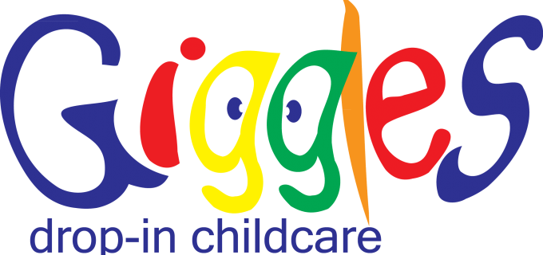

**This business has two locations:**

**Name of Business:** Giggles drop-in childcare of Raleigh

**Address:** 6504 Falls of Neuse Road Suite 150, Raleigh, NC 27615

**Phone Number:** 919-438-1126

**Name of Business:** Giggles drop-in childcare of Cary

**Address:** 267 Grande Heights Drive, Cary, NC 27513

**Phone Number:** 919-468-1001

**Web Address:** gigglesdaycareinc.com

**Discount:** 15% off the hourly rate for care.*Discount does not apply to packages.

**Information:** We are a childcare facility that provides hourly, daily, weekly and monthly care depending on the needs of the parents.